**CODEDEPLOY (hybrid service – works with both EC2 and on-prem)**

* We want to deploy our application automatically
* Works with EC2 instances
* Works with On-prem servers as well
* That’s why it is called Hybrid Service because it works with both – EC2 and on-prem servers
* Servers/Instances must be provisioned and configured ahead of time with the code deploy agent

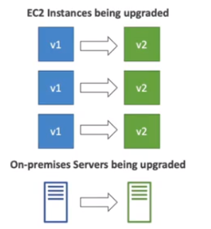

**CODECOMMIT**

* Before pushing the application code to servers, it needs to be stored somewhere
* Developers actually store code in a repository, using the Git technology
* Git -> GitHub ⬄AWS -> Codecommit
* CodeCommit lives only with AWS

**CODEBUILD**

* Code Building service in the cloud
* Compiles source code, run tests, and produces packages that are ready to be deployed (by Codedeploy for ex)
* Benefits:
* Fully managed, serverless
* Continuously scalable and highly available
* Secure
* Pay-as-you-go pricing – only pay for the build time

**AWS CODEPIPELINE**

* Orchestrate the different steps to have the code automatically pushed to production
* Code => Build => Test => Provision => Deploy
* Basis for CI CD
* Benefits:
* Fully managed, compatible with CodeCommit, CodeBuild, CodeDeploy, Elastic Beanstalk, CloudFormation, GitHub, 3rd party services (Github etc.) and custom plugins
* Fast delivery and rapid updates

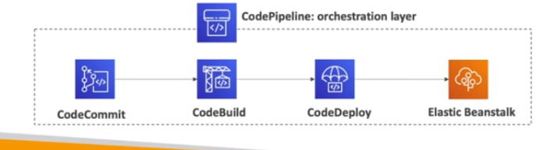

**AWS CODE ARTIFACT**

* Software packages depend on each other to be built, also called code dependencies, and new ones are created
* Storing and retrieving these dependencies is called **artifact management**
* Traditionally, you should setup your own artifact management system
* CodeArtifact is a secure, scalable, and cost-effective artifact management for software development
* Works with common dependency management tool, such as – Maven, Gradle, npm, yarn, twine, pip and NuGet
* Developers and CodeBuild can then retrieve dependencies straight from CodeArtifact

**AWS CODESTAR**

* It is a unified UI to easily manage software development activities in one-place
* “Quick way” to get started to correctly setup CodeCommit, CodePipeline, CodeBuild, CodeDeploy, Elastic Beanstalk, EC2, etc…
* Can edit the code “in-the cloud” using AWS Cloud9

**AWS CLOUD9**

* AWS Cloud9 is a cloud IDE (Integrated Development Environment) for writing, running and debugging code directly in the cloud.
* A cloud IDE – Cloud9 can be directly used in the web browser unlike other IDE tools like – IntelliJ, Visual Studio Code etc., which need to be downloaded before they can be used. This enables developers to work from anywhere with an internet access with no setup necessary
* AWS Cloud9 also allows for code collaboration in real-time (pair programming)